Given the root of a binary tree, return the leftmost value in the last row of the tree.

**Example 1:**

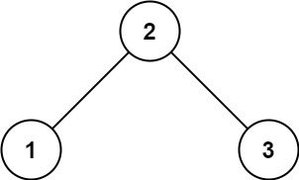

Input: root = [2,1,3]  
Output: 1

**Example 2:**

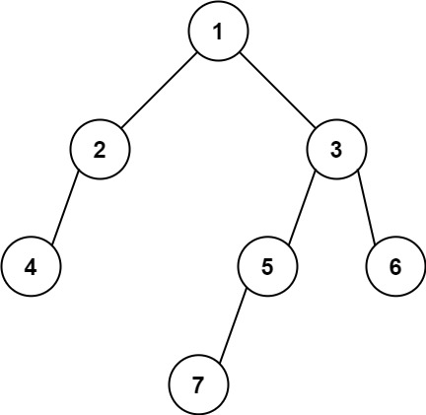

Input: root = [1,2,3,4,null,5,6,null,null,7]  
Output: 7

**Constraints:**

* The number of nodes in the tree is in the range [1, 104].
* -231 <= Node.val <= 231 - 1